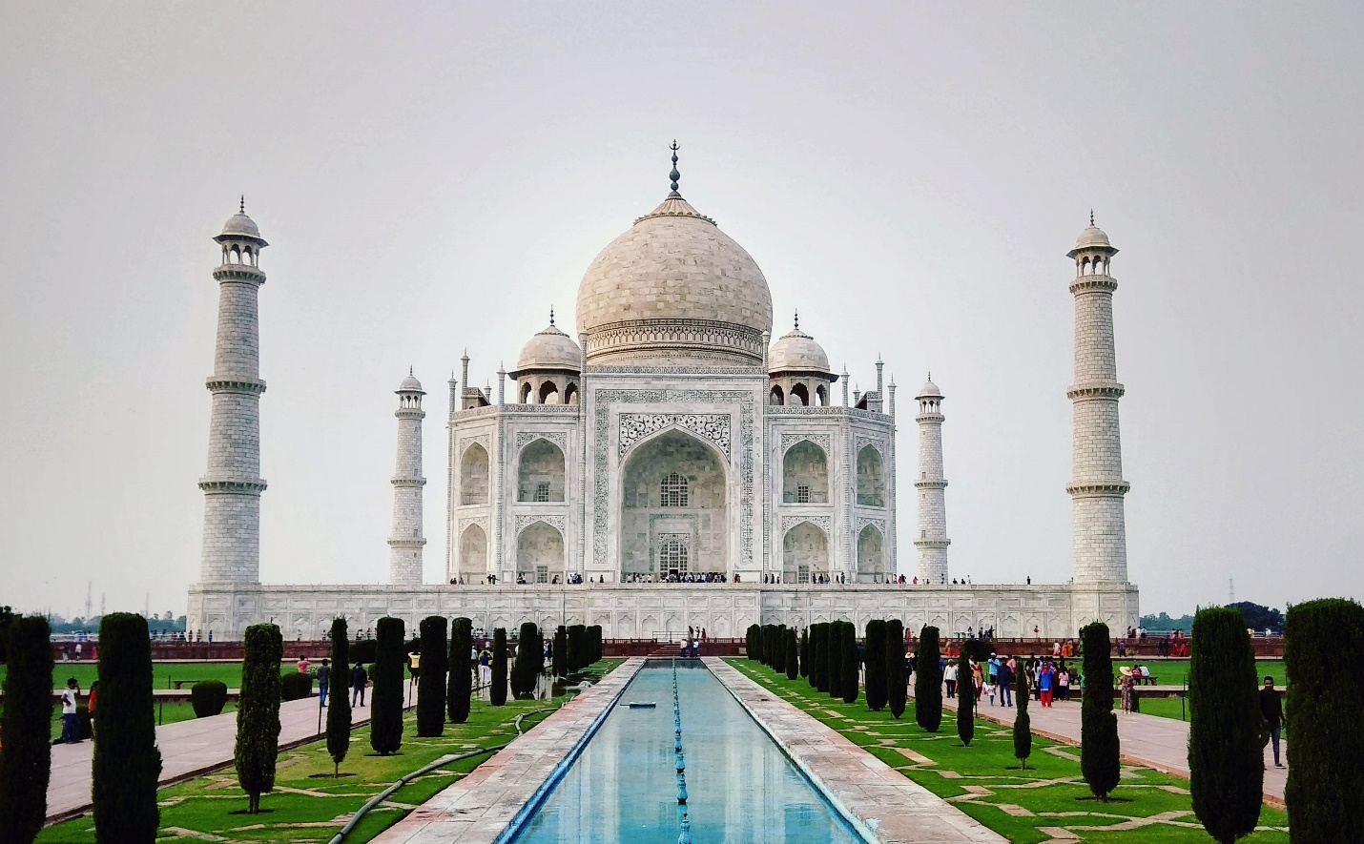

**Taj Mahal**

The **Taj Mahal** is Crown of the Palace is an ivory-white [marble](https://en.wikipedia.org/wiki/Marble) [mausoleum](https://en.wikipedia.org/wiki/Mausoleum) on the right bank of the river [Yamuna](https://en.wikipedia.org/wiki/Yamuna) in [Agra](https://en.wikipedia.org/wiki/Agra), [Uttar Pradesh](https://en.wikipedia.org/wiki/Uttar_Pradesh), India. It was commissioned in 1631 by the fifth [Mughal emperor](https://en.wikipedia.org/wiki/Mughal_Empire), [Shah Jahan](https://en.wikipedia.org/wiki/Shah_Jahan) (r. 1628–1658) to house the tomb of his beloved wife, [Mumtaz Mahal](https://en.wikipedia.org/wiki/Mumtaz_Mahal" \o "Mumtaz Mahal); it also houses the tomb of Shah Jahan himself. The tomb is the centrepiece of a 17-hectare (42-acre) complex, which includes a [mosque](https://en.wikipedia.org/wiki/Mosque) and a guest house, and is set in formal gardens bounded on three sides by a [crenellated](https://en.wikipedia.org/wiki/Crenellated) wall.

Construction of the mausoleum was completed in 1648, but work continued on other phases of the project for another five years. The first ceremony held at the mausoleum was an observance by Shah Jahan, on 6 February 1643, of the 12th anniversary of the death of Mumtaz Mahal. The Taj Mahal complex is believed to have been completed in its entirety in 1653 at a cost estimated at the time to be around [₹](https://en.wikipedia.org/wiki/Indian_rupee)5 million, which in 2023 would be approximately ₹35 billion (US$77.8 million).

The Taj Mahal was designated as a [UNESCO World Heritage Site](https://en.wikipedia.org/wiki/UNESCO_World_Heritage_Site) in 1983 for being "the jewel of [Islamic art](https://en.wikipedia.org/wiki/Islamic_art) in India and one of the universally admired masterpieces of the world's heritage". It is regarded as one of the best examples of Mughal architecture and a symbol of Indian history. The Taj Mahal is a major tourist attraction and attracts more than five million visitors a year. In 2007, it was declared a winner of the [New 7 Wonders of the World](https://en.wikipedia.org/wiki/New_7_Wonders_of_the_World) initiative.

The Taj Mahal was commissioned by [Shah Jahan](https://en.wikipedia.org/wiki/Shah_Jahan) in 1631, to be built in the memory of his wife [Mumtaz Mahal](https://en.wikipedia.org/wiki/Mumtaz_Mahal" \o "Mumtaz Mahal), who died on 17 June that year while giving birth to their 14th child, [Gauhara Begum](https://en.wikipedia.org/wiki/Gauhara_Begum" \o "Gauhara Begum).[[10]](https://en.wikipedia.org/wiki/Taj_Mahal#cite_note-FOOTNOTEAsher1992210-10)[[11]](https://en.wikipedia.org/wiki/Taj_Mahal#cite_note-11) Construction started in 1632, and the mausoleum was completed in 1648, while the surrounding buildings and garden were finished five years later.[[12]](https://en.wikipedia.org/wiki/Taj_Mahal#cite_note-FOOTNOTESarkar191930,_31-12)[[13]](https://en.wikipedia.org/wiki/Taj_Mahal#cite_note-Creation_History-13)

The imperial court documenting Shah Jahan's grief after the death of Mumtaz Mahal illustrates the love story held as the inspiration for the Taj Mahal.[[14]](https://en.wikipedia.org/wiki/Taj_Mahal#cite_note-FOOTNOTEChaghtai193846-14) According to contemporary historians Muhammad Amin Qazvini, [Abdul Hamid Lahori](https://en.wikipedia.org/wiki/Abdul_Hamid_Lahori) and [Muhammad Saleh Kamboh](https://en.wikipedia.org/wiki/Muhammad_Saleh_Kamboh), Shah Jahan did not show the same level of affection for others as he had shown Mumtaz while she was alive. After her death, he avoided royal affairs for a week due to his grief and gave up listening to music and lavish dressing for two years. Shah Jahan was enamored by the beauty of the land at the south side of [Agra](https://en.wikipedia.org/wiki/Agra) on which a mansion belonging to Raja [Jai Singh I](https://en.wikipedia.org/wiki/Jai_Singh_I) stood. He chose the place for the construction of Mumtaz's tomb after which Jai Singh agreed to donate it to the emperor.[[15]](https://en.wikipedia.org/wiki/Taj_Mahal#cite_note-15)